# RASPBERRY

# Single-board computer

<https://it.wikipedia.org/wiki/Computer_a_scheda_singola>

## [Broadcom](https://en.wikipedia.org/wiki/Broadcom) [system on a chip](https://en.wikipedia.org/wiki/System_on_a_chip)

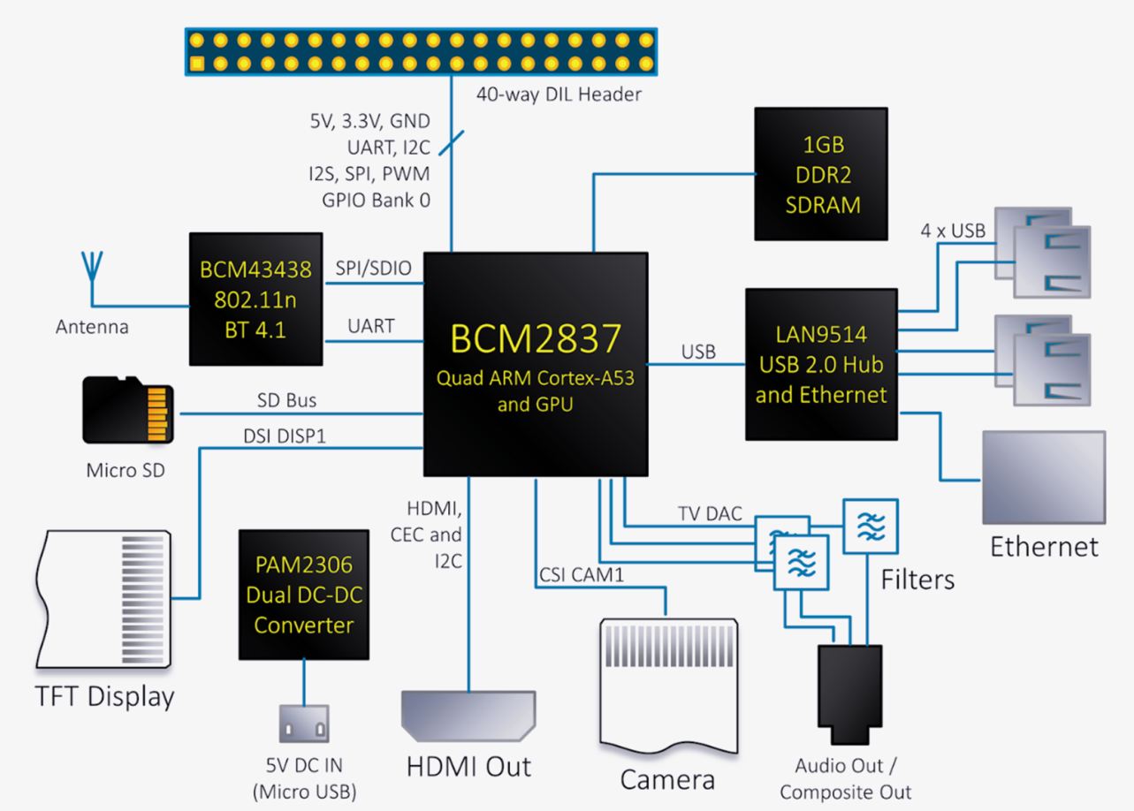

<https://it.wikipedia.org/wiki/System-on-a-chip>

Manca ultimo modello

<https://www.mbtechworks.com/hardware/raspberry-pi-model-comparison.html>

………………………………………………………………………………………………………………………………………………………………………

………………………………………………………………………………………………………………………………………………………………………

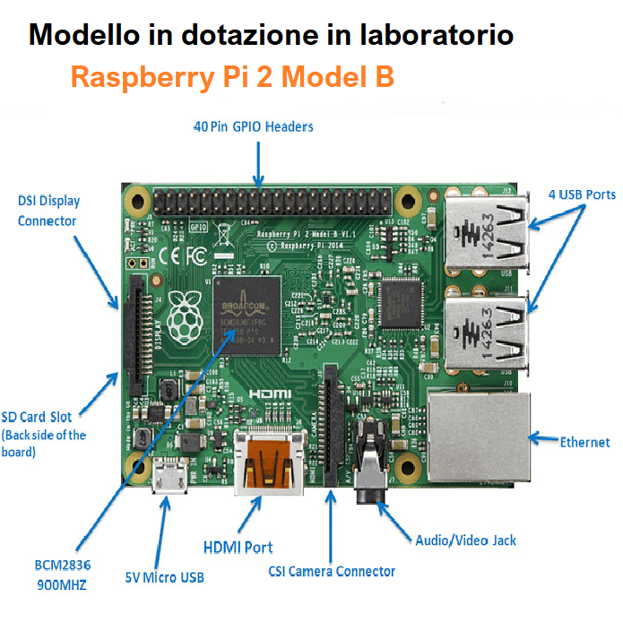+

………………………………………………………………………………………………………………………………………………………………………

………………………………………………………………………………………………………………………………………………………………………

……………………………………………………………………………………………………………………………………………………………………….

………………………………………………………………………………………………………………………………………………………………………

………………………………………………………………………………………………………………………………………………………………………

……………………………………………………………………………………………………………………………………………………………………….

………………………………………………………………………………………………………………………………………………………………………

………………………………………………………………………………………………………………………………………………………………………

………………………………………………………………………………………………………………………………………………………………………

………………………………………………………………………………………………………………………………………………………………………

………………………………………………………………………………………………………………………………………………………………………

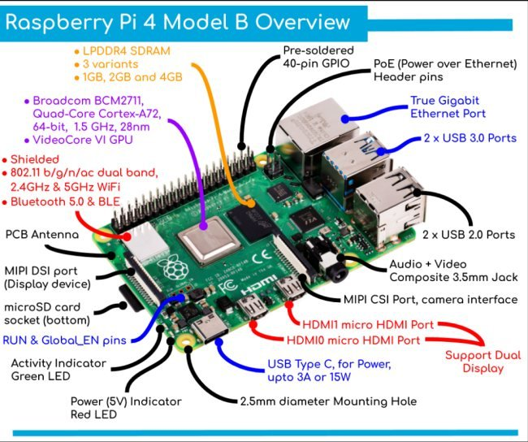

<https://www.ilsoftware.it/public/shots/raspberry_pi_4_model_B_dettagli_funzionamento_0919.jpg>

………………………………………………………………………………………………………………………………………………………………………

………………………………………………………………………………………………………………………………………………………………………

………………………………………………………………………………………………………………………………………………………………………

………………………………………………………………………………………………………………………………………………………………………

………………………………………………………………………………………………………………………………………………………………………

………………………………………………………………………………………………………………………………………………………………………

## Esempio DSI Display

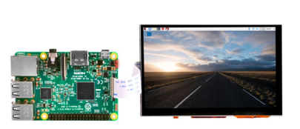

## Esempio CSI Camera

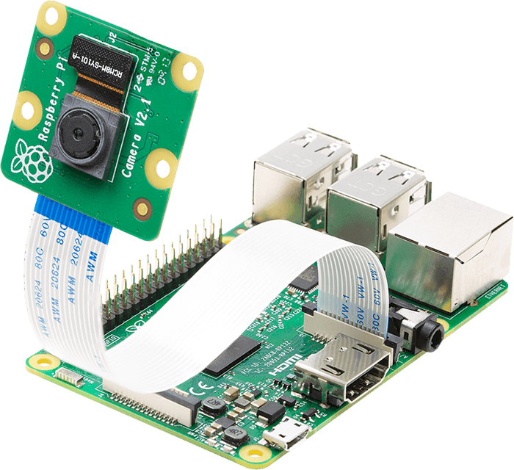

<https://projects.raspberrypi.org/en/projects/getting-started-with-picamera>

………………………………………………………………………………………………………………………………………………………………………

………………………………………………………………………………………………………………………………………………………………………

## Mappatura GPIO

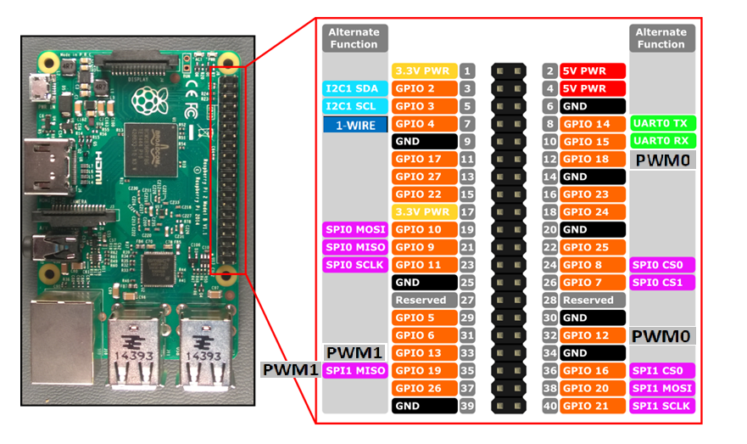

………………………………………………………………………………………………………………………………………………………………………

………………………………………………………………………………………………………………………………………………………………………

……………………………………………………………………………………………………………………………………………………………………….

………………………………………………………………………………………………………………………………………………………………………

………………………………………………………………………………………………………………………………………………………………………

……………………………………………………………………………………………………………………………………………………………………….

………………………………………………………………………………………………………………………………………………………………………

## Esempio OutPut digitale

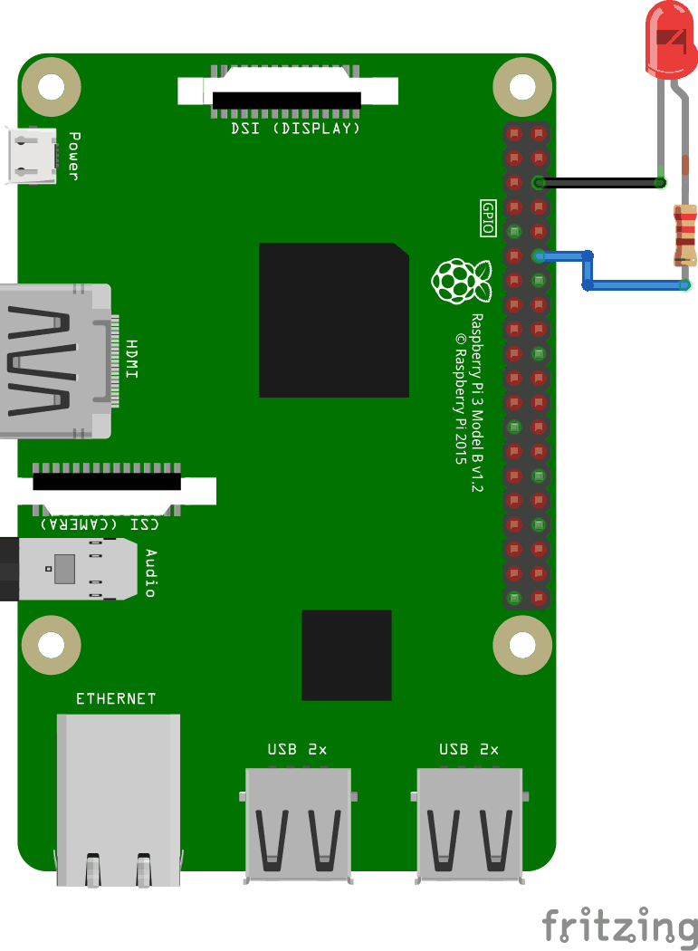

## Esempio Input digitale

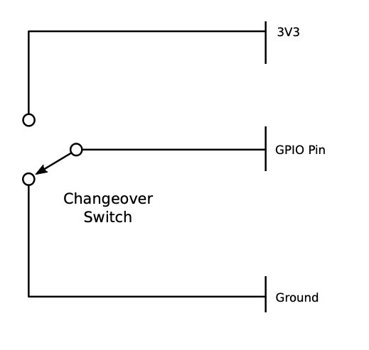

<https://electrosome.com/switch-debouncing/>

## PWM

## 

<https://www.electronicwings.com/public/images/user_images/images/Raspberry%20Pi/RaspberryPi_PWM/PWM.gif>

………………………………………………………………………………………………………………………………………………………………………

………………………………………………………………………………………………………………………………………………………………………

……………………………………………………………………………………………………………………………………………………………………….

………………………………………………………………………………………………………………………………………………………………………

………………………………………………………………………………………………………………………………………………………………………

……………………………………………………………………………………………………………………………………………………………………….

## Esempio collegamento One-Wire devices

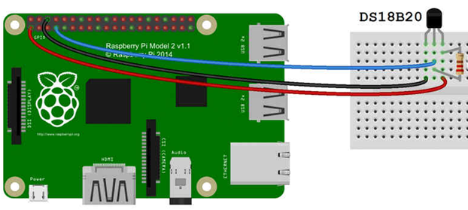

## Esempio collegamento UART devices

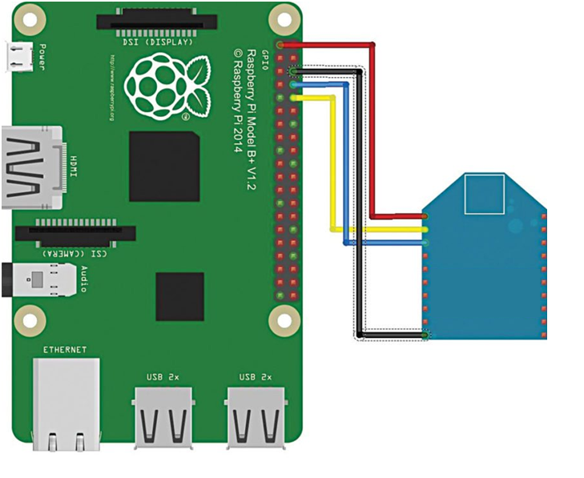

## Esempio collegamento I2C devices

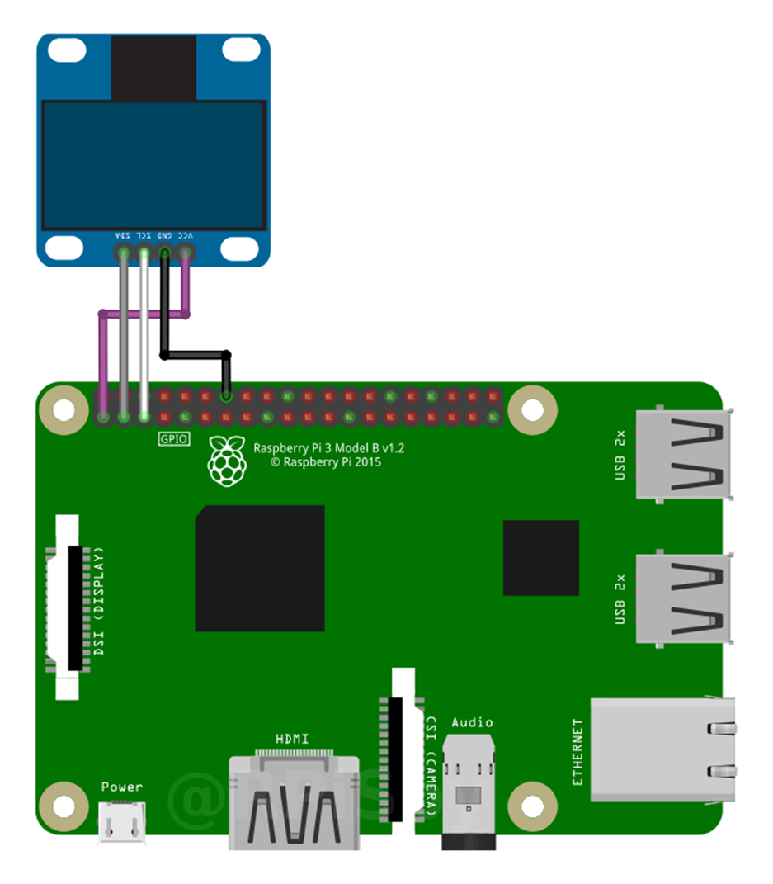

## Esempio collegamento SPI devices

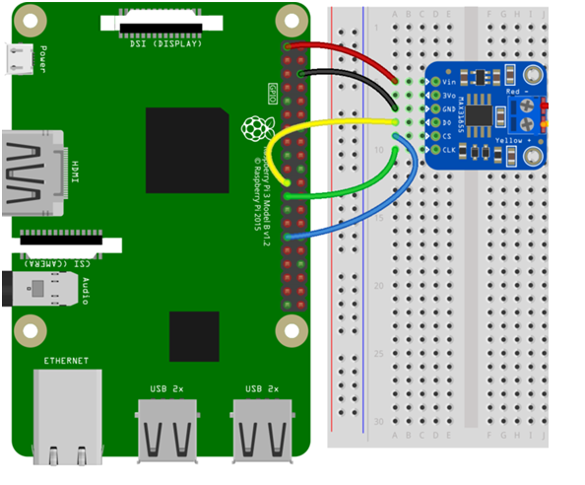

# STRUMENTI UTILI PER UTILIZZARE LA RASPBERRY

#### Scelta della sd Card

<https://lamiacasaelettrica.com/scheda-micro-sd-raspberry-pi>

#### SD Card Formatter

<https://www.sdcard.org/downloads/formatter/sd-memory-card-formatter-for-windows-download/>

#### Download e installazione sistema operativo

<https://www.raspberrypi.com/software/>

#### Copia della SD su file immagine ISO

<https://win32diskimager.org/>

#### Get-fileHash

Windows PowerShell

PS Z:\> Get-fileHash nomefile.est

#### VNC Viewer

<https://www.realvnc.com/en/connect/download/viewer/windows/>

#### FileZilla

<https://filezilla-project.org/download.php?platform=win32>

### PuTTY

<https://www.putty.org/>